TASK 1:

UI/UX : Providing effective solutions for problems using design.

10 Best Experience:

************************

1)Google Search:

-It is world wide search

-It is simple,quick and fast to find all required informations through online

-both educated and uneducated humans can use it using VOICE DETECTION

-It plays major role in daily life

-It meets user requirements

URL: <https://www.google.com/search?q=>

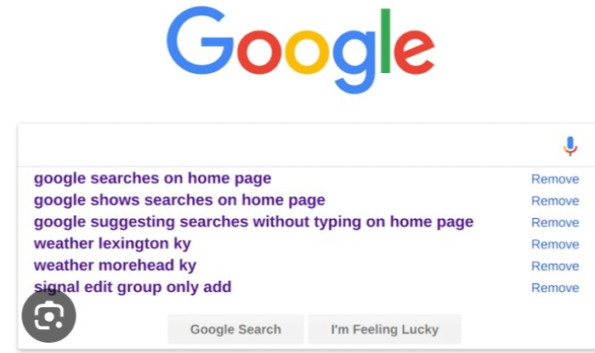

2)Google Maps:

-It is accurate also saves time and communication for both Driver and user

- it is also used to find traveling time and path using map

URL: <https://www.google.com/maps>

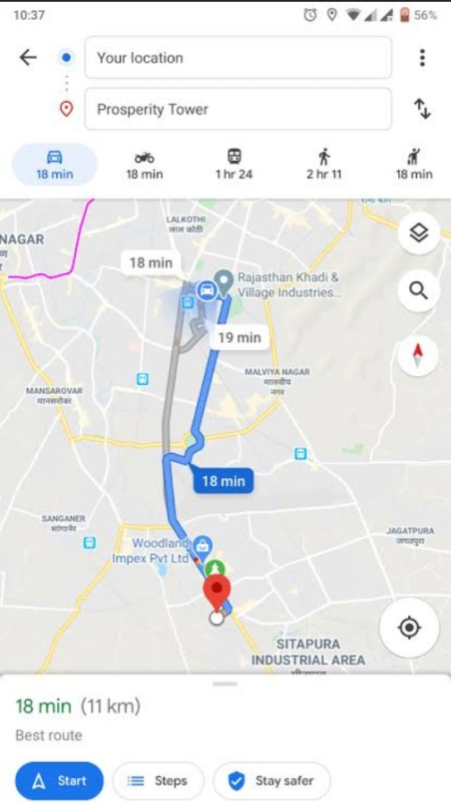

3)Netflix:

- Netflix' is easy-to-use and personalized content

-it is used for both fun and entertainment activities

URL:netflix.com

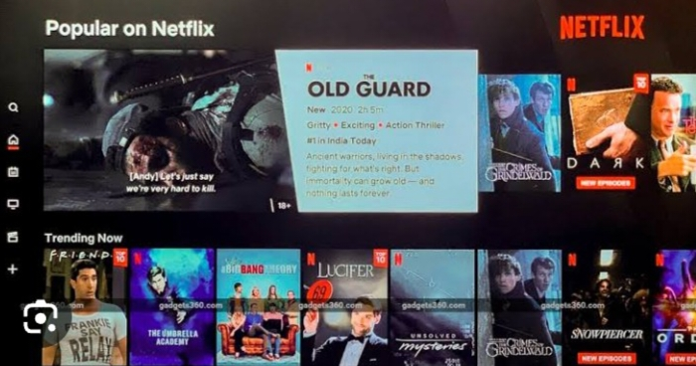

4)GPay/Phone Pay:

-Can do payments easily by scanning QR Code

-used in daily life (i.e)EB BILL PAYMENT

-Fast and simple

-Time consumption

URL:<https://pay.google.com/about/>

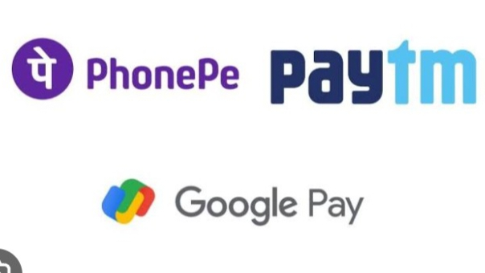

5)Amazon's One-Click Shopping

- one-click shopping feature simplifies the checkout process, reducing friction in the buying experience.

-Returning product it is damaged or if doesnot fulfill our requirements is advantage

-door and hand cash delivery is available

URL: <https://www.amazon.in/s?i=merchant-items&me=A3CTY9BB2UIBO0>

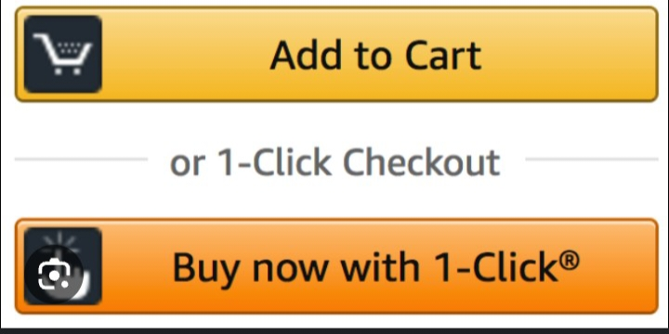

6)Spotify

- Its user-friendly design creates an excellent music streaming experience.

-It is simple and efficient

-used for both fun and entertainment activities

URL: <https://support.symdistro.com/hc/en-us/articles/360039036711-Spotify-How-to-obtain-a-URI-URL>



7)Instagram/Facebook

-It plays major role in daily life.Log in activities are good

-simple and easy accessible and video clarity is best

-can update yourself and communicating with friends and family is simple

URL: <https://vistasocial.com/insights/instagram-url/#:~:text=How%20do%20I%20find%20my,shown%20in%20the%20address%20bar>.



8)Smartphones:

- User friendly mobile interfaces with intuitive touch controls

-it makes work simple and saves time

-Can communicate easily and has many features (Call, texts, voice detection, fingerprint etc....

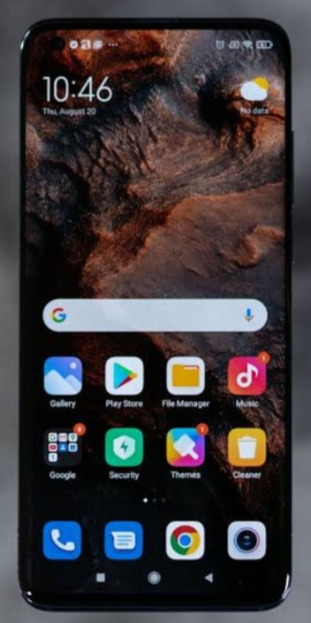

9) Uber/ola:

-Convenient Transportation

--It is saves time and communication for both Driver and user

- it is fast and easy booking

URL:<https://auth.uber.com/v2/?breeze_local_zone=phx5&next_url=https%3A%2F%2Fm.uber.com%2Flogin-redirect%2F%3FpreviousPath%3D%252F&state=w8Am1H9ORQzmdLH3SetQE-h7wWtzNY-zVWAXI7DbL5o%3D>

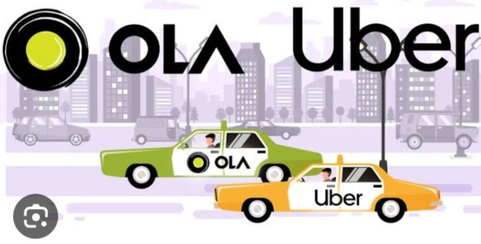

10)Ticket Booking:

-We can book tickets using mobile phones / devices in our home itself

-As per convenience can book seat

=we can also book or cancel in last minute

=-Amount is refundable

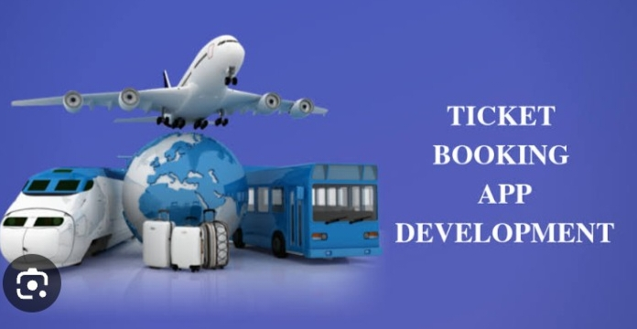

11) ZOMATO/ Swiggy

- Delivered on time

-fast and efficient it is easy to order

-Customer care is good

URL: <https://www.swiggy.com/>

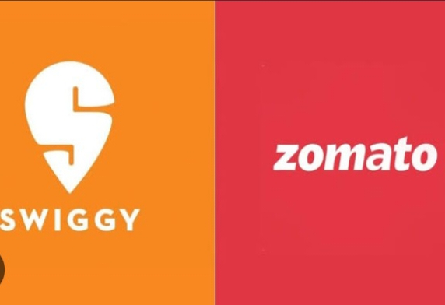

10 Worst User Experiences:

******************************

1)Whatsapp:

- It has been best and worst experience

When it comes to WORK EXperience( IF WE DELETE A MESSAGE AFTER SENT message is deleted but it is notified to opposite person who we send texts)

URL: ttps://wa.me/whatsappphonenumber/?text=urlencodedtext



2)EB bill payment APP:

- It is long procedure 1st we should create account, login, enter password, number etc....

-But using mobile apps are simple and fast

URL:https://www.tnebnet.org/awp/login?locale=ta

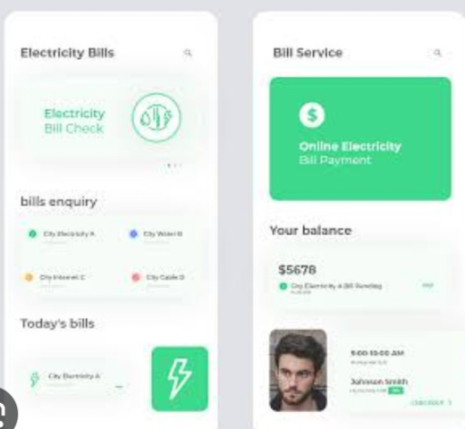

3)Banking

-Once we forget our password we can't login inside app

-It asked to enter old password if we go with forget password and tried to login

URL: <https://www.hdfcbank.com/personal/useful-links/important-messages/stayvigil/hdfc-bank-url>



4)Government website(I.E ANNA UNIVERSITY RESULT PUBLISHMENT)

-Many times server becomes down can't see results on time and it is delayed

-many time portal is not working

-time and energy waste

URL: <https://www.annauniv.edu/>

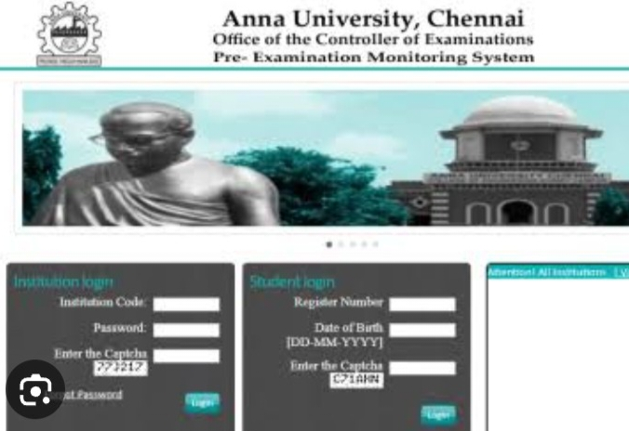

5)Dishwasher Control Panels

- Some dishwasher control panels have unclear icons and buttons

- leading to user confusion.

URL: <https://www.lg.com/us/support/help-library/understanding-dishwasher-control-panel-indicators-CT10000009-20152435193453>

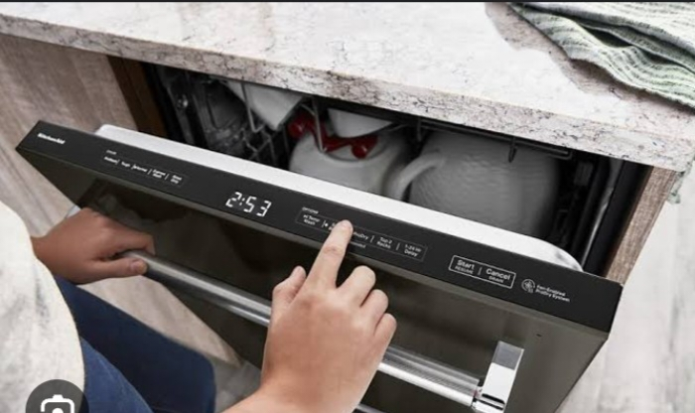

6)Online Forms with Poor Error Handling

- Forms that don't provide clear error messages are frustrating for users when they are trying to submit information

-Some times captcha is not working

URL: <https://accessuse.eu/en/forms-error-handling.html>

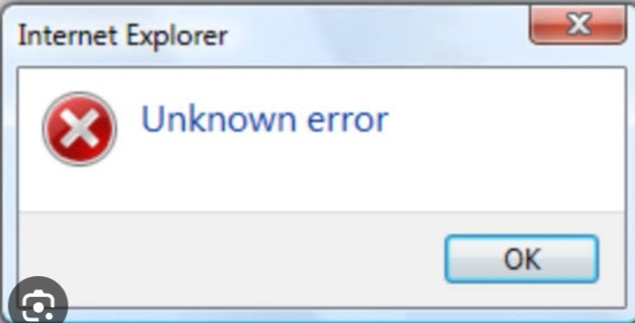

7)Body Temperature Checking appls:

-many times it is not giving accurate results

-it is frustrated

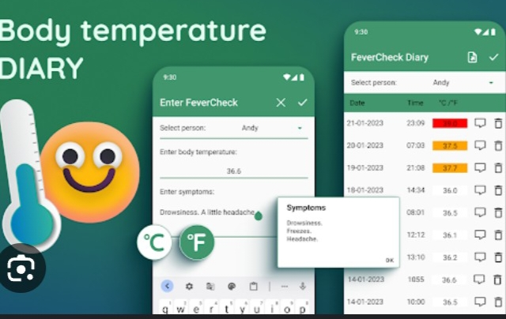

8)Elevator Waiting Times:

- Long waits for elevators in crowded buildings can be inconvenient

-limited number of persons are only allowed

URL: <https://ieeexplore.ieee.org/abstract/document/1341584>

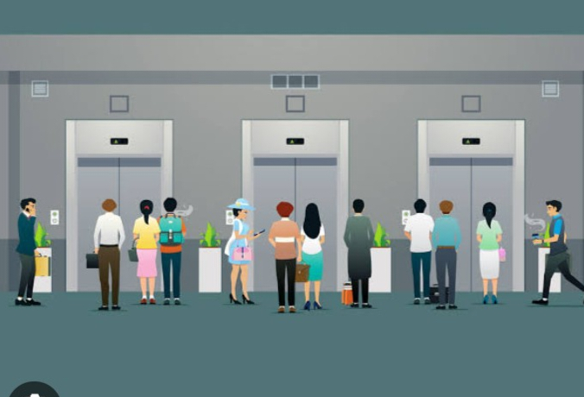

9)printers:

-paper jams, ink problems connectivity issues makes frustrated '

-some time it takes more energy and time

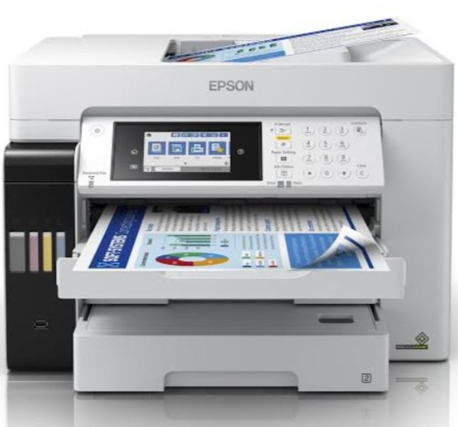

10)Captcha

- Complex captchas can frustrate users and lead to a poor sign-up or login experience.

-Manytimes it is not working

-It takes more energy and time

-Bad experience not meeting customer needs.

URL: www.google.com/**recaptcha**/api/siteverify.com

